ADVANCING THE MANAGEMENT OF RECURRENT VULVAR FUSION: A NOVEL REGENERATIVE PROTOCOL ENHANCED BY SURGICAL INTERVENTION
Authors: ¹Daphne Tansu OMER, ²Berna HALILOGLU PEKER, ³Ozgur LEYLEK
Institution:^{1,2} Maltepe University Hospital, Obstetrics and Gynecology Department, Istanbul,
³Female Private Clinic, Istanbul, Turkey.
Academic titles: Ass.Dr.Daphne Tansu OMER, Prof.Dr.Berna HALILOGLU PEKER,Op.Dr.Ozgur LEYLEK
¹Daphne Tansu OMER Orcid No: 0009-0009-7967-414X
²Berna HALILOGLU PEKER Orcid No: 0000-0002-3166-9052
³Ozgur LEYLEK Orcid No: 0000-0002-7257-0876
City: Istanbul, Türkiye
Phone: +90 531 336 43 45
E-mail: omer.tansu@gmail.com

ABSTRACT
INTRODUCTION
Female genital adhesions are most commonly observed during the prepubertal and childhood periods, where they typically manifest as labial synechiae or labial fusion. In contrast, the condition is considerably less prevalent in postmenopausal women, usually presenting as vulvar fusion as subsequent coalescence of vulvar structures. Here we present a novel regenerative protocol enhanced by surgical intervention.
CASE
An 82-year-old postmenopausal patient was referred with progressive urinary retention and vulvar adhesions with an impaired quality of life. Her medical history revealed breast and cutaneous malignancy treated with radiotherapy. Exploring complete fusion of the labia majora and labia minora, resulting in near-total obliteration of the vulvar vestibule and obscuration of the urethral meatus and vaginal introitus. Patient had undergone surgical adhesiolysis for labial fusion earlier. Despite the initial surgical success, she subsequently developed recurrent and progressively symptomatic vulvar fusion. Comprehensive surgical reconstruction combined with a regenerative therapeutic strategy was planned to restore vulvar anatomy and reduce the risk of re-adhesion.
METHOD
Under general anesthesia sterile in hyperflexion complete fusion of vulva was observed, obscuring the clitoris, vaginal introitus, and urethral meatus. The fused labia majora were initially separated by blunt dissection performed according to standard surgical principles. Subsequently, the clitoral hood and both labia minora were dissected using a sharp dissection. Following adhesiolysis, normal vulvar anatomy was restored. The vaginal introitus and urethral meatus were successfully visualized. The clitoral prepuce and labia minora were sutured using 4-0 Vicryl Rapide sutures. Following hemostasis a 14-Fr Foley catheter was inserted and a local anesthetic and antibiotic impregnated vaginal tampon was placed. During follow-up, the patient underwent two sessions of regenerative therapy using a cellular matrix(RegenLab) which is an injectable medical treatment that combines Platelet-Rich Plasma (PRP) with hyaluronic acid to regenerate tissues. Combining the platelet concentrate(3 ml) served as an autologous reservoir of growth factors, while hyaluronic acid(2 ml), a major component of the extracellular matrix, promoted tissue hydration, supported cellular migration and proliferation, using 6ml blood of patient.(Figure 1-5)
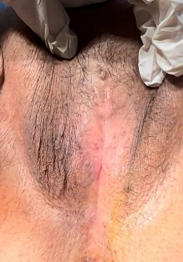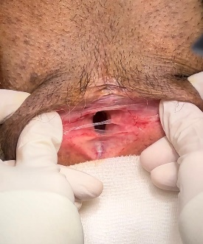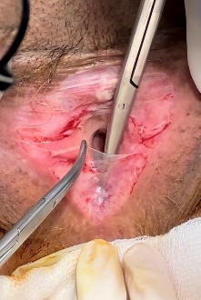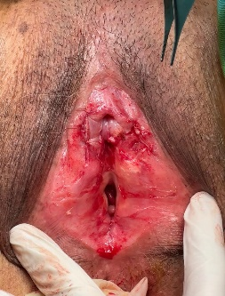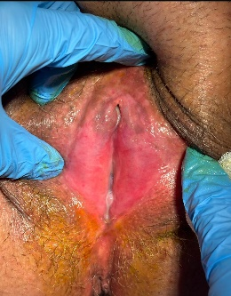
Figure 1-5: Vulvar Fusion Surgical Procedure By Step and Last Figure After Rejuvenation With Cellular Matrix
DISCUSSION AND CONCLUSION
Although studies have attributed labial adhesions to conditions such as hypoestrogenism, sexual inactivity, cervical cancer, hysterectomy, urinary tract infections, and lichen sclerosus, it has also been reported that in prepubertal/reproductive-aged patients, these adhesions may be associated with congenital anomalies and Müllerian duct anomalies (1-2). Surgical intervention is first line treatment option in labial fusion patients but there are many other considerations in second line treatment modalities such as use of topical estrogen, lubricants and others (3-4). In contrast to our case, mild labial fusion has been reported in which, following surgical separation of the labia, a fish skin biograft was used to maintain tissue separation(5). The rationale for reporting this case is to highlight the importance of regenerative maintenance therapy following surgical adhesiolysis. We emphasize that the combination of PRP and hyaluronic acid may provide superior regenerative outcomes compared with PRP alone, potentially enhancing healing and reducing adhesion recurrence.

REFERENCES
- Mahmoudnejad, N., Hamidi Madani, M., & Roohinezhad, R. (2024). The labial adhesion in postmenopausal women: A systematic review. Iranian Journal of Medical Sciences, 49(12), 752–760. https://doi.org/10.30476/ijms.2024.101283.3395
- Liang, Z., Chen, J., Yu, X., & Zhu, L. (2021). Persistent labial minora fusion in reproductive age women: A retrospective case series of nine patients and review of literature. Organogenesis, 17(1–2), 20–25. https://doi.org/10.1080/15476278.2021.1905477
- Arpit, A. V., Nilam, K. P., Smitul, A. V., & Anita, J. S. (2024). Labial fusion in a postmenopausal woman presenting with urinary incontinence. Journal of Midlife Health, 15(3), 217–219. https://doi.org/10.4103/jmh.jmh_107_24
- Sabir, S., Anand, S., & Mendez, M. D. (2026). Labial adhesions. In StatPearls. StatPearls Publishing. https://www.ncbi.nlm.nih.gov/books/NBK...
- Fitzgerald, J. G., Chawla, N., & Kocher, N. J. (2025). Surgical management of complete labial fusion in a postmenopausal woman with application of a fish skin graft: A case report. Case Reports in Women’s Health, 47, e00743. https://doi.org/10.1016/j.crwh.2025.e00743

