CONGENITAL CRESCENTIC HYMENAL EXTENSION AS A RARE CAUSE OF MECHANICAL COITAL OBSTRUCTION DIAGNOSED DURING PREGNANCY: FUNCTIONAL HYMENAL RECONSTRUCTIVE SURGERY AND MATERNAL OUTCOMES
Authors: ¹Daphne Tansu OMER, ²Kasım BAL, ³Ali GURSOY.
Institution: ^{1,2,3}Maltepe University Hospital, Obstetrics and Gynecology Department, Istanbul.
Academic titles: Ass.Dr.Daphne Tansu OMER, Ass.Dr.Kasım BAL Ass.Prof.Dr.Ali GURSOY
City: Istanbul, Türkiye
¹Daphne Tansu OMER Orcid No: 0009-0009-7967-414X
²Kasım BAL Orcid No: 0009-0001-2932-8443
³Ali GURSOY Orcid No: 0000-0001-7275-3800
Phone: +90 531 336 43 45, +90 532 621 40 68
E-mail: omer.tansu@gmail.com, kasimbal07@gmail.com.

ABSTRACT

Introduction
Congenital hymenal abnormalities include a spectrum of developmental variations that may remain undiagnosed until adulthood. Although many cases are asymptomatic, some anomalies may cause dyspareunia, coital dysfunction, infertility-related concerns, or difficulties during gynecological examination. Crescentic hymenal extensions resulting in mechanical obstruction to vaginal penetration are particularly rare. Management during pregnancy presents additional challenges because surgical intervention must balance maternal symptoms with fetal safety. We present a pregnant patient with a congenital crescentic hymenal extension causing severe dyspareunia and inability to achieve vaginal penetration by functional hymenal reconstruction.

Case
A 30-year-old primigravid woman presented at 6 weeks of gestation with severe dyspareunia and inability to complete vaginal intercourse. She reported a long-standing history of pain during attempted sexual intercourse. During gynecological examination, transvaginal ultrasonography could not be performed because of severe pain and introital obstruction.
Physical examination revealed a crescent-shaped hymenal tissue extension extending between the 3 and 9 o’clock positions, creating a substantial mechanical barrier to vaginal penetration.
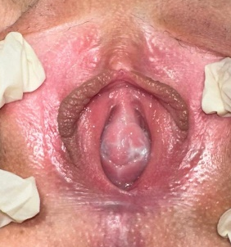
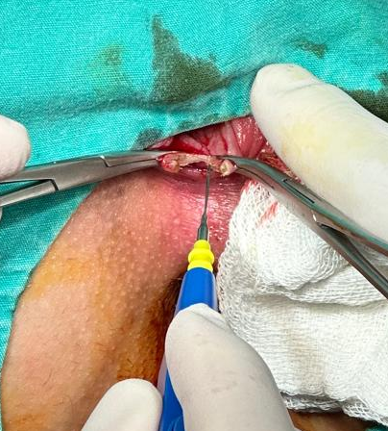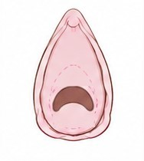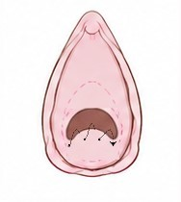
Figure 1-4: Hymenal crescentic extention following electrocautery and demonstration of suture line.
Following multidisciplinary counseling, surgical intervention during the first trimester was deferred because of concerns regarding anesthetic exposure during early pregnancy and the absence of an urgent indication.
At 28 weeks of gestation, the patient continued to experience significant dyspareunia and impaired sexual function. Surgical correction was therefore planned. After confirmation of fetal cardiac activity, the procedure was performed under sedoanalgesia. The hymenal extension was grasped at the 3, 6, and 9 o’clock positions and excised using electrocautery. Increased genital tract vascularity associated with pregnancy resulted in persistent bleeding despite cauterization, requiring additional hemostatic sutures with 3-0 polyglactin. Hemostasis was successfully achieved, and the procedure was completed without maternal-fetal complications. Postoperative recovery was uneventfull and sexual intercourse was restricted for one month.

Discussion and Conclusion
Congenital crescentic hymenal extension is a rare cause of severe dyspareunia, coital dysfunction, and inability to perform transvaginal ultrasonography. There are cases reporting obstructive uropathy and constipation in children diagnosed with imperforate congenital hymen in contrast to our case which is microperforated due to crescentic hymenal extantion(1). Just like in our case there are imperforate hymen cases in which also electrocautery is used to make an anular hymenotomy rather than using a cold knife(2). There have been reported cases of miscarriage due tue microperforated hymen unlikely to our case in which we performed the surgery safely during pregnancy(3). Microperforated hymen can cause infection, miscarriage and evenually infertility in women in contrast to our case. Hymenal reconstruction should be performed in carefully selected patients with persistent symptoms and significant mechanical obstruction. Increased tissue vascularity during pregnancy may complicate hemostasis and should be considered during surgical planning. In addition to relieving dyspareunia and restoring normal introital anatomy, surgical correction may improve vaginal compliance before delivery. We want to point out that third trimester safety operations could be performed to improve sexual life and further vaginal delivery option to the patient rather than waiting for the term pregnancy unlikly to other case reports(4).

References
- Tedyanto, C. P., Dewi, S., Santoso, F. I., Ere, M. A. P., & Oeylex, K. R. (2024). A rare case report of a congenital imperforate hymen causing obstructive uropathy and constipation in an 11-year-old girl. International Medical Case Reports Journal, 17, 985–989. https://doi.org/10.2147/IMCRJ.S494697
- Cetin, C., Soysal, C., Khatib, G., Urunsak, I. F., & Cetin, T. (2016). Annular hymenotomy for imperforate hymen. Journal of Obstetrics and Gynaecology Research, 42(8), 1013–1015. https://doi.org/10.1111/jog.13010
- Ganti, S., Senathirajah, T., Govindarajan, R., & Srinivasan, J. (2024). Microperforate hymen: A rare case of pregnancy and miscarriage. Cureus, 16(8), e67517. https://doi.org/10.7759/cureus.67517
- Elshani, B., Arifi, H., & Daci, A. (2018). Microperforated hymen presenting spontaneous pregnancy with cesarean delivery and hymenotomy surgery: A case report. Open Access Macedonian Journal of Medical Sciences, 6(3), 528–530. https://doi.org/10.3889/oamjms.2018.123.

