URETHRAL RECONSTRUCTION OF AN URETHRAL CARUNCLE MIMICKING POSTMENOPAUSAL BLEEDING: A RARE DIAGNOSTIC CHALLENGE
Authors: ¹Daphne Tansu OMER, ²Hasan SOYDAN, ³Furkan BINGOLOGLU, ⁴Ali GURSOY
Institution: ^{1,4}Maltepe University Hospital, Obstetrics and Gynecology Department, Istanbul, ^{2,3}Maltepe University Hospital, Urology Department, Istanbul.
Academic titles: Ass.Dr.Daphne Tansu OMER, Prof.Dr.Hasan SOYDAN, Ass.Dr.Furkan BINGOLOGLU, Assoc.Prof.Dr.Ali GURSOY.
City: Istanbul, Türkiye
¹Daphne Tansu OMER Orcid No: 0009-0009-7967-414X
²Prof.Dr.Hasan SOYDAN Orcid No: 0000-0003-3631-7141
³Ass.Dr. Furkan BINGOLOGLU Orcid No: 0009-0008-6342-7243
⁴Ali GURSOY Orcid No: 0000-0001-7275-3800
Phone: +90 531 336 43 45
E-mail: omer.tansu@gmail.com

ABSTRACT

Introduction
Postmenopausal bleeding is a clinically significant symptom that requires prompt investigation because of its association with gynecological malignancies. Although most cases originate from the genital tract, extra-gynecological conditions may occasionally mimic vaginal bleeding and create diagnostic challenges(1-2). Urethral caruncle is the most common benign lesion of the female urethra and rarely presents as apparent vaginal bleeding. We present a case of urethral caruncle causing postmenopausal bleeding and requiring urethral reconstruction following surgical excision.

Case
An 82-year-old woman presented with intermittent postmenopausal bleeding. She had been menopausal for approximately 35 years. Gynecological examination revealed an atrophic vagina and a normal-appearing cervix without active bleeding. Transvaginal ultrasonography demonstrated an atrophic uterus with an endometrial thickness of 7 mm, while both ovaries appeared atrophic. Detailed examination identified erythema, edema, and a protruding lesion at the external urethral meatus. Following urological consultation, contrast-enhanced pelvic magnetic resonance imaging (MRI) demonstrated focal thickening and increased signal intensity around the urethral outlet, suggestive of a localized inflammatory or proliferative lesion. Endometrial sampling was performed because of the increased endometrial thickness and revealed benign histopathological findings.
The patient was diagnosed with a urethral caruncle and underwent complete surgical excision. Under general anesthesia, the prolapsed distal urethral mucosa was circumferentially excised following placement of stay sutures at standardized clock-face positions. Urethral reconstruction was subsequently performed using interrupted absorbable sutures, and a 16-Fr Foley catheter was inserted. The procedure was completed without complications.(Figure 1-5)
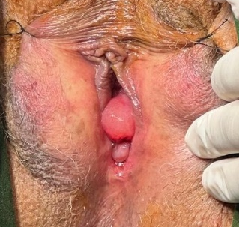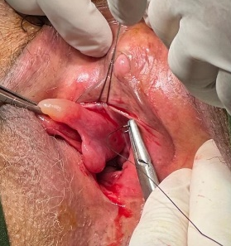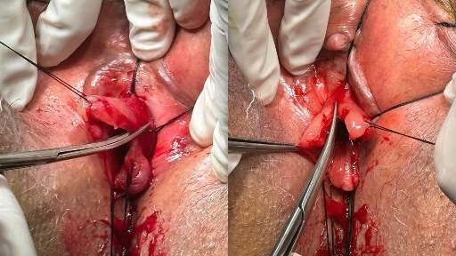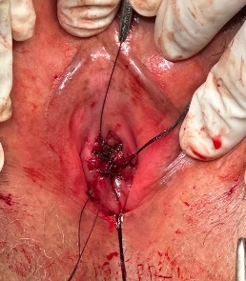
Figure 1-5: Urethral Reconstruction Of An Urethral Caruncle Step By Step
Postoperative recovery was uneventful. The catheter was removed after satisfactory healing. During follow-up, no urinary retention, urethral stenosis, recurrent bleeding, voiding dysfunction, or lesion recurrence was observed.

Discussion and Conclusion
Urethral caruncle should be considered in the differential diagnosis of postmenopausal bleeding, particularly when routine gynecological evaluation fails to identify a definitive source. Careful inspection of the periurethral region is essential to avoid delayed diagnosis and unnecessary investigations. This case demonstrates that symptomatic urethral caruncles may successfully be treated by complete excision and urethral reconstruction. Preservation of urethral caliber during reconstruction is critical for preventing postoperative urinary retention, urethral stenosis, and other voiding complications. Awareness of this uncommon etiology may facilitate accurate diagnosis and appropriate management in postmenopausal women presenting with apparent vaginal bleeding. One more attention should be paid in urethral caruncles that malignant melanomas may present as urethral caruncles that is why pathological examination is important while reconstruction of distal urethral meatus that is why the excised urethral tissue was analised by pathologist revealing of benign result in our case(3). There are also cases in which due to a large reconstruction mash could be used in reparation unlikely to our case(4).
References
- Zuo, S. W., & Napoe, G. S. (2023). Evaluation and management of urethral and periurethral masses in women. Curr Op Obstet Gynecol, 35(6), 517-524. https://doi.org/10.1097/GCO.0000000000000914
- Meutia, A. P., Yonathan, K., & Widia, F. (2021). Giant urethral caruncle resembling urethral prolapse causing outflow obstruction. Urol Case Rep, 39, 101783. https://doi.org/10.1016/j.eucr.2021.101783
- Slyby, J. R., Harper, A. K., & Aldrich, E. R. (2026). Melanoma presenting as a urethral caruncle. Menopause, 33(6), 754-756. https://doi.org/10.1097/GME.0000000000002719
- Xie, J., Liu, B., Li, J., & Luo, Z. (2020). "Sandwich" mesh reconstruction of female giant urethral diverticulum: a case report. BMC Urol, 20(1), 32. https://doi.org/10.1186/s12894-020-00598-2

